

DCM Blood Glucose Monitor

Project DCM Medical Devices
version 0.93

Content
1. Version Management (Revision History) 3
2. (Concept) 3
3. Mindmap (Mindmap) 3
4. Doel (Purpose) 3
Doelstelling (Purpose of DCM) 3
Reden (Reason for DCM use) 3
Groep cliënten (Patient population) 3
5. Wetenschappelijke onderbouwing (Evidence Base) 4
6. Informatie Model (Information Model) 5
7. Voorbeeld scenario (Example Instances) 7
8. Werkwijze (Instructions) 7
9. Interpretatierichtlijnen (Interpretation) 7
10. Zorgproces / afhankelijkheid (Care Process) 8
11. Een voorbeeld van het instrument (Example of the Instrument) 8
12. Inperkingen (Constraints) 8
13. Issues en openstaande vragen (Issues) 8
14. Referenties (References) 8
15. (Functional Model) 10
16. Traceerbaarheid naar andere standaarden (Traceability to other Standards) 10
17. Disclaimer (Disclaimer) 10
18. Gebruiksvoorwaarden (Terms of Use) 10
19. Copyrights (Copyrights) 11

Version Management (Revision History)
The versions 0.1 - 0.93 are draft versions because the DCM is under development.
Version 0.93 will be discussed as an example in the DCM Medical devices project.

(Concept)
This DCM concerns the Blood Glucose Monitor. The Blood Glucose Monitor is a portable device used to measure the blood glucose level by using a drop of blood. All concepts concerning the Blood Glucose Monitor will be attended to in this DCM.

Mindmap (Mindmap)
Not available

Doel (Purpose)
For self monitoring of the blood glucose the patient need to have a blood glucose monitor. Besides that the monitor should be used in the right way and needs to be controlled regulary.
For the treatmentplan this relevant information needs to be recorded in the EHR of the patient.

Doelstelling (Purpose of DCM)
Registration of the general information and quality monitoring information of the blood glucose monitor.

Reden (Reason for DCM use)
A blood glucose monitor needs to be used correctly and needs to comply to quality demands that need to be monitored regularly.

Groep cliënten (Patient population)
Patients that possess a blood glucose monitor.

Wetenschappelijke onderbouwing (Evidence Base)
In the NDF Zorgstandaard (Dutch Diabetes Federation Standard of Care) of 2007 it is described that de standard serves as basis for an individual care and treatment plan. This individual plan is drawn by the attending physician in dialogue with the patient. In the individual care and treatment plan all that is of importance in the care and treatment of the patient concerning Diabetes Mellitus is recorded. With the individual plan the patient will get more insight in the process of the disease. The individual plan also stimulates and reinforces the role of the patient in monitoring the progress of the process of the disease. The NDF has the opinion that in this way the responsibility for one’s own health is put more directly at the patient himself. Self-control of blood glucose can contribute to the self management of Diabetes Mellitus. By self-control the patient gains more insight in factors that determine the blood glucose values. More insight from the patient can lead to a better regulation of the blood glucose. This can prevent, delay or reduce complications.

For the self-control of the blood glucose the patient uses the blood glucose monitor. The blood glucose monitor needs to be reliable, because the result is used to determine the dosage of insulin. Taking too much or too little insulin can lead to complaints and even hypoglycemia or hyperglycemia. On the long term damage can occur on the blood vessels among others.
A research conducted by Slingerland et al. (2006) has shown that a little less than 20% of the blood glucose monitors with a CE mark, on the Dutch market meet the criteria in the TNO (Dutch Institute for Applied Scientific Research) guideline. Abnormalities in the results of the blood glucose measurement can have major consequences. Boyd and Bruns (2000) have demonstrated in their research that glucose measurement results that deviate more than (more or less) seven percent if the reference values can give rise to a wrong insulin dosage.

It is therefore not only important that patient are in the possession of a glucose monitor for self monitoring, but it is definitely also important that the quality of this glucose monitor is good. For this quality TNO and others have developed a guideline and NEN has a norm based on ISO to which manufacturers of blood glucose monitors need to comply (TNO, 2001; NEN, 2005).
It is also important that blood glucose monitors of patients need to be checked every year. (Isala, 2009; apotheken Rijk van Nijmegen, 2007; Kringapotheken, 2009). In addition, checking is important if the patient has doubts about the functioning of the blood glucose monitor.

Informatie Model (Information Model)

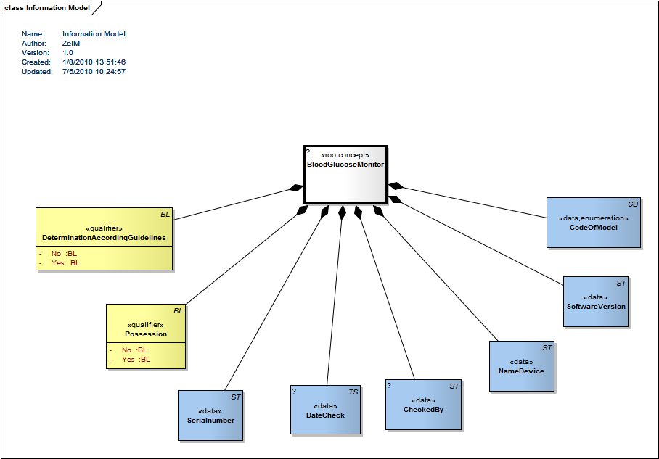
Diagram 1: Information Model

Concept | Definition
BloodGlucoseMonitor | Information that is of importance to the care and treatment plan.
Tags | DCM::CodeSystem.Id | 2.16.840.1.113883.6.96
Tags | DCM::CodeSystem.Name | Snomed CT
Tags | DCM::DefinitionCode1 | SCT: 337414009 blood glucose meters
Tags | DCM::DEfinitionCode2 | LOINC: 43151-0 Glucose Meter Device Pnl

Concept | Definition
CheckedBy | Name of the person who checked the blood glucose monitor. This person can be employed by a laboratory of a hospital or at a pharmacy.

Concept | Definition
CodeOfModel | The code of the model of the blood glucose monitor. For example from a classification for medical devices or Cliq? If it is a code of the device itself, a choice list needs to be added to this variable, the code that belongs to that is this one.
Tags | DCM::DefinitionCode | LOINC: 41898-8 Vendor device model code

Concept | Definition
DateCheck | Date when the blood glucose monitor has been checked.

Concept | Definition
DeterminationAccordingGuidelines | Assessment of the method used to determine the blood glucose. This needs to be done following the appropriate guidelines.
Tags | DCM::DefinitionCode | EVN NEDB02610: Determination of Blood Glucose according to Guidelines

Concept | Definition
NameDevice | Name of the blood glucose monitor according to the manufacturer / supplier. For examples http://www.mijnbloedglucosemeter.nl.
Tags | DCM::DefinitionCode | LOINC: 41897-0 Vendor device name

Concept | Definition
Possession | For selfcontrol of blood glucose the patients need to possess a blood glucose monitor.
Tags | DCM::DefinitionCode | EVN NEDB02600: Possession Blood Glucose Meter

Concept | Definition
Serialnumber | The serial number of the blood glucose monitor.
Tags | DCM::DefinitionCode | LOINC: 41899-6 Vendor serial number

Concept | Definition
SoftwareVersion | De software en de versie die door de fabrikant wordt gebruikt.
Tags | DCM::DefinitionCode | LOINC: 41900-2 Vendor software version

Voorbeeld scenario (Example Instances)

not available

Werkwijze (Instructions)
In the individual care and treatment plan is recorded whether the patient has a blood glucose monitor for self-control. In addition it is recorded whether the determination of the blood glucose is done according to the applicable guidelines.
For the reliability of the blood glucose monitor it needs to be checked annually or when the patient doubts the correctly functioning of his blood glucose monitor. In the individual care and treatment plan it is recorded when the check is done and who conducted it.

Interpretatierichtlijnen (Interpretation)
An annually checked blood glucose monitor is reliable for conducting self-control. A patient that feels responsible for his own health will show involvement by self-control and the checking of the blood glucose monitor.
If the determination of the blood glucose is not done following the guidelines education can be given.
In the context of the DCM on the blood glucose monitor it is not useful to attend to the interpretation of the blood glucose levels, that is done in the DCM on blood glucose itself.

Zorgproces / afhankelijkheid (Care Process)
For the self-control of the blood glucose het patient needs a blood glucose monitor. As described this monitor needs to meet certain requirements. Therefore the monitor needs to be checked annually. The results of the blood glucose measurement contribute to the correct dosage of insulin.

Een voorbeeld van het instrument (Example of the Instrument)

Inperkingen (Constraints)

Issues en openstaande vragen (Issues)
In the information model there are some data elements coming from the eDiabetes Basis Dataset; possession, checked by, date check and determination according guidelines.

The other data elements are coming from LOINC and other sources.

Discussion: are these data elements common elements for each medical device? Can they be part of the general DCM of Medical devices?

Another discussion is the code for the rootconcept. I used a LOINC code for that: blood glucose monitor panel. Can a code for a panel be used in this way?

Assumption: The actual blood glucose is been handled in another DCM. In that DCM the DCM Blood Glucose Monitor is applied as a slot.

Validation issues to be solved:

DCMCC-15: Expected exactly 1 "DCM::ContentAuthorList" Tagged Value on the DCM root-Package
DCMCC-15: Expected exactly 1 "DCM::KeywordList" Tagged Value on the DCM root-Package
DCMCC-15: Expected exactly 1 "DCM::DescriptionLanguage" Tagged Value on the DCM root-Package
DCMCC-15: Expected exactly 1 "DCM::CreationDate" Tagged Value on the DCM root-Package
DCMCC-15: Expected exactly 1 "DCM::LifecycleStatus" Tagged Value on the DCM root-Package
DCMCC-17: Expected the name of the DCM root-Package to be "Blood Glucose Monitor-v0.93" but got "Blood Glucose Monitor "
DCMCC-14: Expected "0.93" as Information Model Diagram Version but got "1.0"
DCMCC-09: "CheckedBy" expected at least 1 DCM::DefinitionCode Tagged Value
DCMCC-09: "DateCheck" expected at least 1 DCM::DefinitionCode Tagged Value
DCMCC-26: "DeterminationAccordingGuidelines" DCM::DefinitionCode has a not accepted codeSystemName
DCMCC-??: "DeterminationAccordingGuidelines" expected attribute "No" to be "enum" but got ""
DCMCC-08: "DeterminationAccordingGuidelines" expected attribute "No" visibility to be "Public" but got "Private"
DCMCC-??: "DeterminationAccordingGuidelines" expected attribute "Yes" to be "enum" but got ""
DCMCC-08: "DeterminationAccordingGuidelines" expected attribute "Yes" visibility to be "Public" but got "Private"
DCMCC-26: "Possession" DCM::DefinitionCode has a not accepted codeSystemName
DCMCC-??: "Possession" expected attribute "Yes" to be "enum" but got ""
DCMCC-08: "Possession" expected attribute "Yes" visibility to be "Public" but got "Private"
DCMCC-??: "Possession" expected attribute "No" to be "enum" but got ""
DCMCC-08: "Possession" expected attribute "No" visibility to be "Public" but got "Private"

Referenties (References)
Projects:
eDiabetes project, Nictiz

Literature:
- Controle en instructie bij het gebruik van een bloedglucosemeter Informatie voor mensen met diabetes mellitus. Obtained om 12 maart 2009, from http://www.isala.nl

- Diabetesservice. Obtained on 12 maart 2009, from http://www.kring-apotheek.nl/

- Is mijn bloedglucosemeter betrouwbaar?. Obtained on 12 maart 2009, from http://www.efarma.nl

- Keten DBC diabetes: de bijdrage van de apotheker,Versie 01 (16 november 2006). Obtained on 12 maart 2009, from http://www.knmp.nl

- Nederlandse Diabetesfederatie (NDF), (2007). NDF Zorgstandaard. Transparantie en kwaliteit van diabeteszorg voor mensen met diabetes type 2. Amersfoort, NDF.

- NEN, (2005). NEN-EN-ISO 15197/C11:2005 In vitro diagnostische beproevingssystemen - Eisen voor bloedglucose monitoringsystemen voor zelftesten ten behoeve van het reguleren van diabetes mellitus. Delft, NEN.

- Overzicht bloedglucosemeters. Obtained on 12 maart 2009, from http://www.mijnbloedglucosemeter.nl

- Redactie Gezondgids, (2006). Glucosemeters onder vuur. Gezondgids, november 2006, 4.

- Slingerland, R.J., Muller, W., Dollahmoersid, R., Witteveen, C., Meeues, J.T., Blerk van, I. Gouka-Tseng C., Vroonhof, K., (2006). The Quality of blood glucose meters in the netherlands 5 years after introduction of the CE/IVD directive. Nederlands Tijdschrift voor Klinische Chemie en Laboratoriumgeneeskunde, 32: 202-204.

- Standaard Farmaceutische patiëntenzorg (FPZ) Diabetes mellitus, Rijk van Nijmegen (2007). Obtained on 12 maart 2009, from www.knmp-nijmegen.nl

- TNO, (2001). TNO Quality Guideline PG/TG/2001.045 Portable in-vitro blood monitor systems for (self)-monitoring - Blood Glucose Monitors – Particular requirements and test methods. Leiden, TNO.

Vocabulary:
SNOMED CT 2.16.840.1.113883.6.96
LOINC 2.16.840.113883.6.1
NDF Observation ?
It is possible that people in this domain use different codes and value sets than those used in this DCM. In that case, we as developers would appreciate it if we were informed of this.
For the coding the use of terminologies like SNOMED CT and/or LOINC, or one of the classifications of the WHO family of classifications (for example ICD10, ICF, ICNP) has been preferred. The codes that are used are, by our opinion the best possible match between the data item (variable and/or value) and the concept/ concepts as set out in the terminology or classification.
It is possible that a very rigorous analysis of one of these terminologies variations emerge that are just as good or even a better match, for instance if another perspective is chosen. There is a small chance that in the future codes for certain data items are being altered.
Where we did not find a code, for now, Results 4 Care codes were made and missing concepts will be asked to SNOMED CT.

(Functional Model)

Traceerbaarheid naar andere standaarden (Traceability to other Standards)

Disclaimer (Disclaimer)
Results 4 Care B.V. gives the utmost care to the reliability and timeliness of data in this DCM, Detailed Clinical Model. Errors and inaccuracies may occur. Results 4 Care is not responsible for damages resulting from errors or inaccuracies in the information, nor for damages arising from problems caused by, or inherent in the spreading of information via the Internet, as failures or interruptions from either errors or delays in the distribution of information or services by Results 4 Care, by means of the website repository or by e-mail, or otherwise electronically.
Results 4 care does not accept responsibility for possible damage suffered as a result of the use of data, advise or ideas provided by way of this DCM. Results 4 Care does not accept responsibility for the content of information in this DCM to which or from which using a hyperlink or otherwise, is referred.
In case of contradictions in the mentioned DCM documents and files the priority of the relevant documents is stated by the most recent and highest version mentioned in the revision (version management).
In case information that is included in the electronic version of this DCM is also provided in writing, in case of textual differences the written version will determine. This applies if the version description and date of both are equal. The definitive version has priority over a concept version. A revised version has priority over a previous version.

Gebruiksvoorwaarden (Terms of Use)
Use of the DCM
The DCM is open source, so free to use, not to be changed.
Changes in the content en codes are seen upon as a infringement of copyright and is damaging for the goal of use: realisation of semantic interoperability.
You can suggest changes at results4care@cs.com
Revision suggestions will be looked at and may lead to:
- revised DCM and results if accepted
- variations of the DCM adapted on a local situation.
This is all based upon : a “common ownership” but not a “special stewardship”

Copyrights (Copyrights)
Licenses of source material
Not applicable

